Test case ID | Test Scenario | Test Steps | Tested Environment | Test Data | Actual output | Expected Out put | Remarks | Status
TC-01 | Log in with correct Username and Password | 1)Open the application through URL  2)Enter valid Username  3)Enter Valid Password  4)click on Submit button  5)Navigate through Home page | https://demo.guru99.com/V4/index.php | Username: mngr666618  Password: ydYregu | User should be login, navigate through Home page. | User should be login, navigate through Homme page. | Test case is passed | Pass

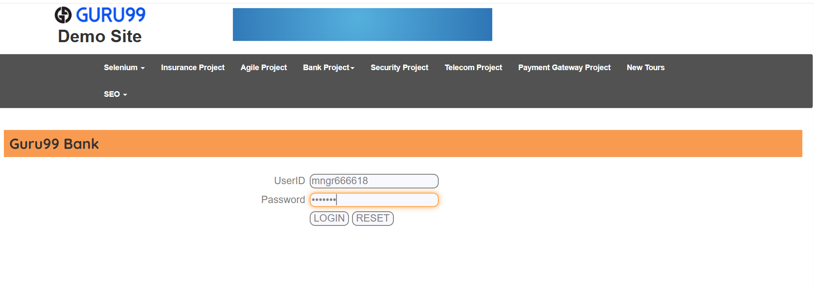

Test case ID | Test Scenario | Test Steps | Tested Environment | Test Data | Actual output | Expected Out put | Remarks | Status
TC-02 | Create a New Customer | 1)Open the application through URL  2)Enter valid Username  3)Enter Valid Password  4)click on Submit button  5)Navigate through Home page  6)Click on New Customer  7)Enter the Datails  (Username,Gender,Date of Birth,Address,City,State,PIN,Mobile Number, E-Mail,Password).  8)Click on Submit | https://demo.guru99.com/V4/index.php | Customer name:rajesh  Gender:Male  Birth Date:2005-06-10  Address:Kalagara  City:Vijayawada  State:Andhara Pradesh  Pin:521214  Mobile No.: 9876543210  E-Mail:vakas8817@gmail.com  Password:Vrlsv@2000. | A new user should be created successfulley. | Anew should be created successfulley. | Test case is passed | Pass
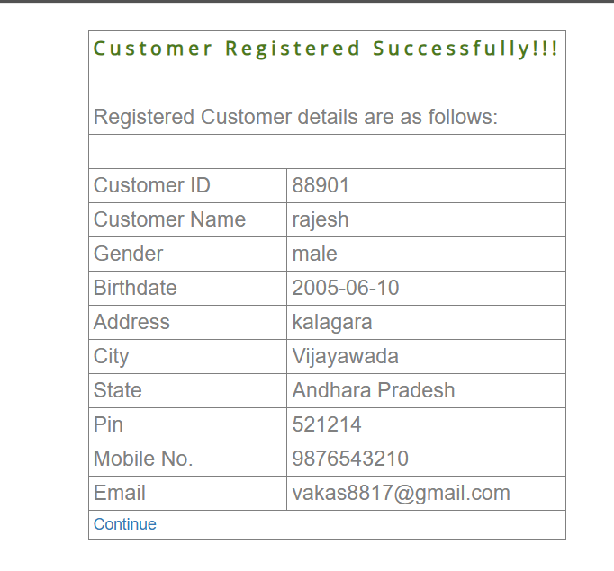

Test case ID | Test Scenario | Test Steps | Tested Environment | Test Data | Actual output | Expected Out put | Remarks | Status
TC-03 | Logout Functionality | 1)Open the application through URL  2)Enter valid Username  3)Enter Valid Password  4)click on Submit button  5)Navigate through Home page  6)Click on Logout. | https://demo.guru99.com/V4/index.php | Logout Functionality | User should be logout from home page. | User should be logout from home page. | Test case is passed | Pass

